Distance Unit Conversion Plan

The output of the assignment is to accept the given distance value by the user then converting to either kilometers to miles or vise versa from an option selection. The process of the assignment will be followed as:
- Insert constants for unit conversions.
- Make a function for the calculation, reset, quit.
- Insert two options for kilometers to miles and miles to kilometers.
- Display the unit result that the user inputted.
List Control | Identify Properties
Window | geometry(“200x200”)  title(“Kilomiles Calculator”)
Label_Distance | text= “Distance”  grid row = 0  grid column = 0
Entry_Distance | grid row = 1  grid column = 1
Reset button | text= “Reset”  width= 10  command= reset_button()  grid row = 4  grid column = 1
Quit button | text= “Quit”  width= 15  command= quit_button()  grid row = 4  grid column = 0
Kilometers Radio button | Text=”Kilometers to miles”  Value=1
Miles Radio button | Text=”miles to kilometers”  Value=2
Label_Result | text= “Result”  grid row = 0  grid column = 0
Entry_Result | grid row = 1  grid column = 1

The layout of the program will be described as:
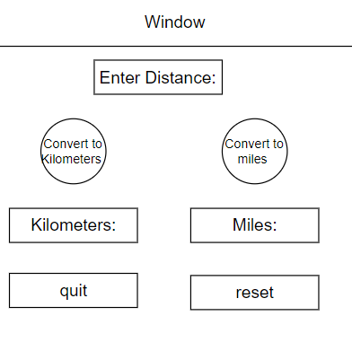
The pseudo-plan is planned as the following steps:
from tkinker import*
KILOMETERS TO MILES: 0.6214
MILES TO KILOMETERS: 1.6093
#Make the window
window = Tk()
window.title=(“KiloMiles Calculator”)
window.geometry(“200x200”)
#Include label distance
Label(window, text=”Distance”, font=(“Arial”, 15)), fg=‘Red’).grid(row=0, column=0)
Distance = FloatVar()
#Include entry distance
Entry(window, textvariable=Distance, font=(“Arial”, 15)).grid(row=1, column=1)
#Make the choice for kilometers to miles
r1 = Radiobutton(window, text=”kilometers to miles”, command=kilo to miles)
r1.grid(row=1, column=2)
#Make the choice for miles to kilometers
r2 = Radiobutton(window, text=”miles to kilo”, command=miles to kilo)
r2.grid(row=1, column=2)

#Include label result
Label(window, text="Result”, font=(“Arial”, 15)), fg=‘Purple’).grid(row=4 column=0)
#Include entry result
Label(window, textvariable=Result).grid(row=4 column=0)
#Make the quit button
button = Button(window, text=”Quit”, command=quit_button, fg = ‘orange’)
button.grid(row=4,column=0, columnspan=2)
#Make the refresh button
button = Button(window, text=”Reset”, command=reset_button, fg = ‘blue’)
button.grid(row=4,column=0, columnspan=2)
#Mainloop to start the program
window.mainloop()

Desk-Check:
Negative numbers will not be allowed
Only float values will be allowed
No limitation for conversion values
Distance will be converted to kilometers or miles
Reset button will refresh all inputs and return everything
Quit button will exit the window

